The Assistance of The School Health Unit "UKS" Development to Optimize Health among Elementary Students

Henik Tri Rahayu¹*, Anis Ika Nur Rohmah²
¹Nursing Science Study Program, Faculty of Health Sciences, University of Muhammadiyah Malang, Indonesia
Corresponding Author: Henik Tri Rahayu: trirahayu@umm.ac.id

A R T I C L E I N F O | A B S T R A C T
Keywords: school-age children, health education, optimizing School Health Unit  Received : 17, December  Revised : 22, January  Accepted: 20, February  ©2023 Rahayu, Rohmah: This is an open-access article distributed under the terms of the Creative Commons Atribusi 4.0 Internasional.   | School health units (in Indonesian abbreviation as "UKS") in educational institutions can sustain healthy behavior and optimize student growth and development. The lack of UKS facilities and no particular UKS supervisors resulted in several health problems among the school members. From these problems, the solutions offered by this community service activity included: support for optimizing/revitalizing UKS functions and health education/counseling related to existing problems to support or improve the health of school members, especially students. This community service has been carried out by providing training and coaching for UKS cadres in the context of empowering UKS cadres to support health in schools. The training materials include first aid management, wound care, and healthy foods. This community service's outcomes include increasing partners' knowledge and skills.

INTRODUCTION
The partner of this community service is a public elementary school located in the Kromengan (sub-district-Malang Regency, East Java Indonesia), a rural area quite far from the city center. This village is far from accessing various adequate health facilities, and the only closest health facility is the public health center "Puskesmas." Like several other primary schools in the area, the children at this school have some common health problems. The school period is a transitional period for them to adjust to their various developmental tasks. To complete their developmental tasks and problems, elementary school-aged children need assistance from adult people, especially in the health sector.
Some of this school's students' health problems include some students experiencing metabolic disorders and eating problems, such as; around 35% of students are obese, and around 25% of students reported having eating disorders such as picky eating and eating unhealthy snacks. Metabolic and eating disorders are issues of concern to the Indonesian Ministry of Health. This health problem can reduce the quality of children's intelligence and various diseases that will be caused in the future, such as diabetes and digestive diseases. In addition, we also found oral health problems; around 15% of students had dental caries. Dental health can affect physical and psychosocial health. Dental caries can increase the colonization of bacteria that can affect the health of blood vessels and the heart in adults. Then, the psychosocial problems that arise are being shunned by friends because of bad breath.
The school health unit in Indonesia is called UKS (an abbreviation of Unit Kesehatan Sekolah), which based on the Decree of the Minister of Health No. 828/MENKES/SK/IX/2008, is an integrated cross-program and cross-sectoral efforts to improve the ability to live healthily and then shape the healthy life behavior of school-age children who are at school. This school health unit in educational institutions roles to can sustain healthy behavior and optimize student growth and development (Direktorat Sekolah Dasar, 2022). UKS is an effort by the education unit to instill, grow, develop, and improve the ability to live a healthy life by implementing Clean and Healthy Behavior (PHBS=Perilaku Hidup Bersih dan Sehat), as well as the health status of students through the implementation of the UKS Trias (health education, health services, and healthy environment development) (Direktorat Sekolah Dasar, 2022; Direktorat Sekolah Menengah Pertama, 2022).
However, UKS in this school has not been running optimally. Actually, the UKS unit at this school has an organizational structure, but it was not active. Apart from that, the facilities at UKS are still minimal/poor, and the approach is still conventional; for example, there are very few first aids medicines, and there is only “Revanol”, a wound medicine that has been abandoned for a long time. Whereas during elementary school, there was a high incidence of accidents at school due to sports or playing. The Little Doctor program also exists in this school and has been supported by the healthcare team from the public health center. However, since the Covid-19 pandemic, this activity has been discontinued. It is regrettable because UKS and Little Doctors program should be able to play a role in improving the health of school residents, not only as a place of reference when there is a minor accident or a student who is sick during school hours. So that this community service program supports the development of UKS at this school and expected will help improve the function of the UKS and the health of school residents in general.
The UKS cadres are students who meet the criteria and have been trained to participate in carrying out some efforts to maintain and improve health for themselves, friends, family, and their environment. During school hours, they usually help teachers take care of students who need help with their health. For instance, they are on guard during the flag ceremony in case a friend gets sick or faints or someone has an accident during exercise hours or playing. Thus, increasing their knowledge and skills was essential, particularly in giving basic first aid on superficial and minor wounds. Therefore, this community service program aims to increase students' health knowledge and skills and provide more adequate UKS health facilities.

IMPLEMENTATION AND METHODS
This community service focuses on revitalizing UKS cadres and functions. This community service uses mentoring and teaching methods to transfer health knowledge, including combining lecture methods, demonstrations, discussions, and role-plays with giving rewards. Then, to support the UKS facilities, the community service teams also provide support for UKS facilities such as mattresses and pillows for UKS, digital weight scales, thermometers, and wound care sets with essential emergency medicines to provide for better UKS activities.
Some of the solutions offered and implemented include training on skills and basic knowledge that UKS cadres must have, such as wound care, management of minor injuries due to sports accidents, and management of fainting. This community service comprises several stages: field assessment to examine school problems and needs, mentoring for UKS cadres, and evaluation. Evaluation of the program's level of success where assessing using one of the indicators of increasing knowledge through the pre-post test of cadres' knowledge of the material presented.

RESULTS AND DISCUSSION
This community service is expected to positively impact the elementary school as the partner of this community service program, particularly in revitalizing the UKS program.
Out of 19 UKS cadres consisting of students in grades 4,5,6 whom the school teacher had selected. Only include these grades, considering that students in at least grade 4 are ready and more mature than in previous grades. Thus, it assumed that they were more able to receive the knowledge and skills to help others. The majority showed increased knowledge scores after training (mean pre-test: 35; post-test 80). In the training process, students who were active and got the best grades were given prizes in the form of drink bottles, lunchboxes, and notebooks. It stimulates other children to be more active and participatory.
Health lecturing and training of nursing care or intervention of basic first aid for minor injuries and simple health problems, through demonstrations, role-play a situational practice played by UKS cadre students to help the cadres has able to improve first aid knowledge and skills in mild and simple cases that might be encountered in the school environment. Using demonstration in teaching enhances students' understanding of the materials (Logar & Savec, 2011; Zimmerman & Jaffe, 1977). Also, role-playing among elementary and young learners increases the understanding and level of students' remembering of the course (Agboola Sogunro, 2004; Kerawalla et al., 2006; Spencer et al., 2019). The development of UKS cadres is significant because UKS cadres will be one of the frontlines that can play a role in improving the health of school members. The students of these cadres are equipped with first aid skills, for example, if they find a friend who has fainted due to a flag ceremony, minor sports injuries, and others.
From the evaluation of the activities, most participants said that the activities were enjoyable, and they were delighted because they were given training. The school also said they were grateful because service activities like this benefited them in helping to improve the quality of the school. The school hopes there will be similar activities in the future with different materials. Moreover, since this school is in the same area as another elementary school, which has the conditions and facilities are much less inadequate, the head of the school expects that future activities can include two schools as the community service partner.

The following pictures document our community service activities and situations at partner locations.
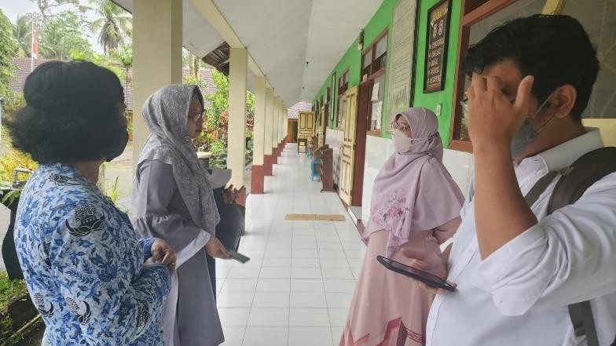
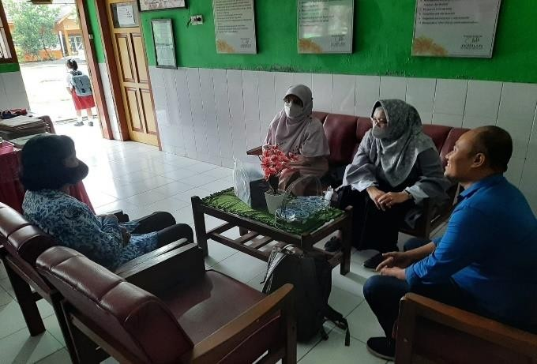
a)
b)
Picture 1. (a) Coordination with related
principals and teacher Picture.2 Field Assessment
and school facilities

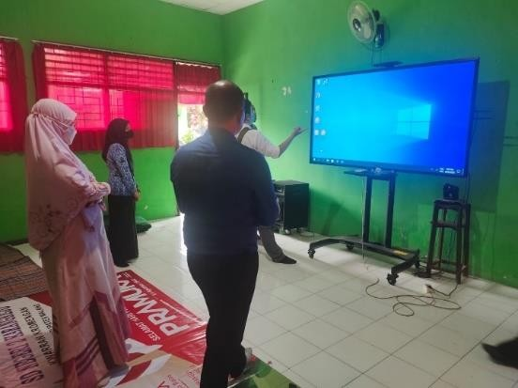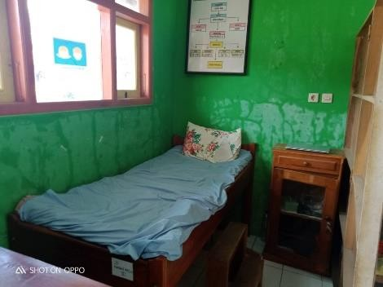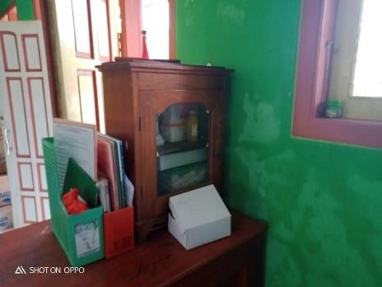
Picture 3. Poor UKS facilities

Activity 2: Training Program
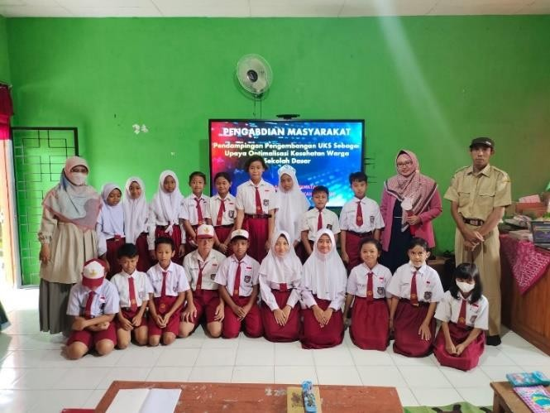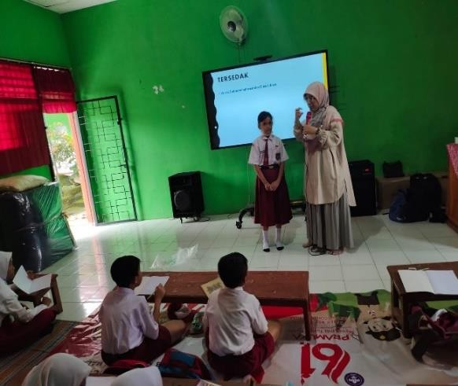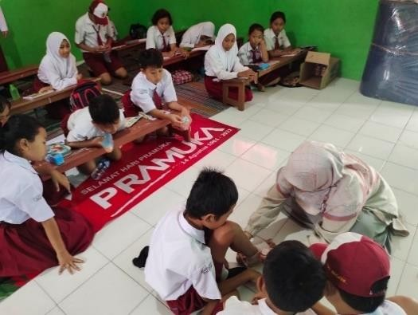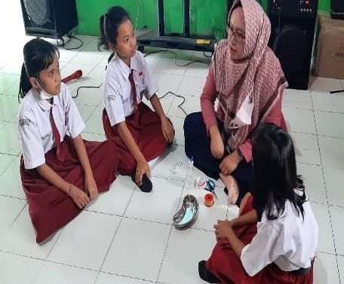
Picture 6. Practicum of simple musculoskeletal injuries intervention
Picture 7. Practicum of basic wound management
Picture 4. UKS cadres and supervisor
Picture 5. Health education and training

CONCLUSION AND RECOMMENDATIONS
This community service is one of the most valuable activities for elementary schools as partners. Increasing the knowledge and skills of UKS cadres as actors in the health team in elementary schools is one of the efforts to improve the quality of service and the quality of elementary schools. Health education, mentoring with skill demonstrations, playing role plays caring for peers are suitable and liked by students at the elementary school level so that the material can be received quickly and enjoyable. University assistance activities to other elementary schools can continue to be carried out to help improve the quality of elementary schools, especially schools that are far from urban centers and still need much development. University community service program particularly in helping elementary school were highly important to support communities.

ACKNOWLEDGMENT
The Author would like to thank the University of Muhammadiyah Malang, Indonesia, for financially supporting this community program.

BIBLIOGRAPHY
Agboola Sogunro, O. (2004). Efficacy of role‐playing pedagogy in training leaders: some reflections. Journal of Management Development, 23(4), 355–371.

Direktorat Sekolah Dasar. (2022). Usaha Kesehatan Sekolah (UKS). https://ditpsd.kemdikbud.go.id/hal/usaha-kesehatan-sekolah

Direktorat Sekolah Menengah Pertama. (2022). Peran dan Tanggung Jawab Kader Kesehatan Sekolah dalam Program Gizi UKS. https://ditsmp.kemdikbud.go.id/peran-dan-tanggung-jawab-kader-kesehatan-sekolah-dalam-program-gizi-uks/

Kerawalla, L., Luckin, R., Seljeflot, S., & Woolard, A. (2006). "Making it real": exploring the potential of augmented reality for teaching primary school science. Virtual Reality, 10, 163–174.

Logar, A., & Savec, V. F. (2011). Students' Hands-on Experimental Work vs Lecture Demonstration in Teaching Elementary School Chemistry. Acta Chimica Slovenica, 58(4).

Spencer, S., Drescher, T., Sears, J., Scruggs, A. F., & Schreffler, J. (2019). Comparing the efficacy of virtual simulation to traditional classroom role-play. Journal of Educational Computing Research, 57(7), 1772–1785.

Zimmerman, B. J., & Jaffe, A. (1977). Teaching through demonstration: The effects of structuring, imitation, and age. Journal of Educational Psychology, 69(6), 773.

